**JAVA PROGRAMMING**

**ASSIGNMENT**

**Try them using collection framework**

1. **Program for string reversal without using inbuilt function**

**Program:**

import java.util.*;

public class StringReverse

{

public static void main(String[] args) {

ArrayList<String> list=new ArrayList<String>();

Scanner sc=new Scanner(System.in);

System.out.println("Enter the String to Reverse: ");

String st=sc.next();

char ct;

String element="";

for(int i=0;i<st.length();i++)

{

ct=st.charAt(i);

String s=Character.toString(ct);

list.add(s);

}

for(int i=list.size()-1;i>=0;i--)

{

element=element+list.get(i);

}

System.out.println("Reverse of the string without using string-inbuilt method: "+element);

} }

**Output:**

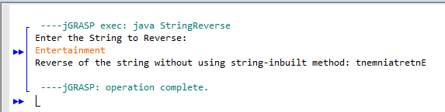

1. **Program for binary search – in linked list**

import java.util.*;

public class SearchLinkedList

{

public int binarySearch(int low,int high,LinkedList<Integer> list,int search_element)

{

int mid;

if(high>=low)

{

mid=(low+(high-1))/2;

if(search_element==list.get(mid))

{

return mid;

}

if(search_element>list.get(mid))

{

return binarySearch(mid+1,high,list,search_element);

}

return binarySearch(low,mid-1,list,search_element);

}

else{

return -1; }

}

public static void main(String[] args) {

LinkedList<Integer> list=new LinkedList<Integer>();

Scanner sc=new Scanner(System.in);

System.out.println("Enter the number of elements you want: ");

int no_element=sc.nextInt();

int element;

System.out.println("Enter "+no_element+" elements: ");

for(int i=0;i<no_element;i++)

{

element=sc.nextInt();

list.add(element);

}

System.out.println("Enter the element you want to search: ");

int search_element=sc.nextInt();

int high,low;

Collections.sort(list);

System.out.println("Sorted list: "+list);

low=0;

high=(list.size())-1;

SearchLinkedList m=new SearchLinkedList();

int res;

res=m.binarySearch(low,high,list,search_element);

if(res>-1)

{

System.out.println("Element "+search_element+" found");

}

else

{

System.out.println("Element "+search_element+" not found");

}

}

}

**Output:**

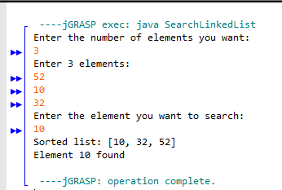 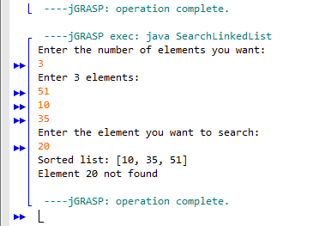

1. **Given an element write a program to check if element (value) exists in ArrayList?**

**Program:**

import java.util.*;

public class Main

{

public static void main(String[] args) {

ArrayList<Integer> list=new ArrayList<Integer>();

Scanner sc=new Scanner(System.in);

System.out.println("Enter the number of elements you want: ");

int no_element=sc.nextInt();

int element;

System.out.println("Enter "+no_element+" elements: ");

for(int i=0;i<no_element;i++)

{

element=sc.nextInt();

list.add(element);

}

System.out.println("Enter the element you want to check whether it exists or not: ");

int search_element=sc.nextInt();

int res=0;

for(int i=0;i<list.size();i++)

{

if(search_element==(list.get(i)))

{

res=1;

break;

}

else

{

res=0;

}

}

if(res==1)

{

System.out.println("The element "+search_element+" exists in the ArrayList");

}

else

{

System.out.println("The element "+search_element+" does not exists in the ArrayList");

}

}

}

**Output:**

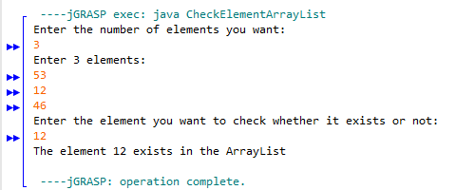

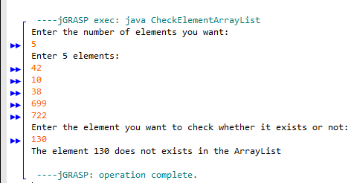

1. **Write a program to remove element from specified index of ArrayList?**

**Program:**

import java.util.*;

public class Main

{

public static void main(String[] args) {

ArrayList<Integer> list=new ArrayList<Integer>();

Scanner sc=new Scanner(System.in);

System.out.println("Enter the number of elements you want: ");

int no_element=sc.nextInt();

int element;

System.out.println("Enter "+no_element+" elements: ");

for(int i=0;i<no_element;i++)

{

element=sc.nextInt();

list.add(element);

}

System.out.println("Enter the element you want to remove from a specified index: ");

int remove_element=sc.nextInt();

System.out.println("List before the removal of the specified element:"+list);

int position=list.indexOf(remove_element);

list.remove(position);

System.out.println("List after the removal of the specified element: "+list);

}

}

**Output:**

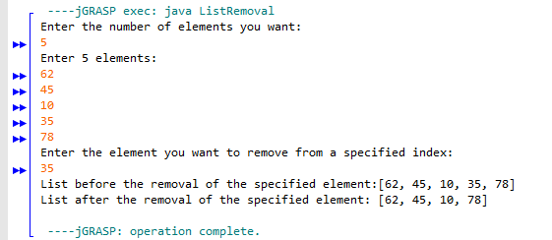

1. **Program to check if the given string is a palindrome.**

**Program:**

import java.util.*;

public class StringPalindrome

{

public static void main(String[] args) {

ArrayList<String> list=new ArrayList<String>();

Scanner sc=new Scanner(System.in);

System.out.println("Enter the String to Reverse: ");

String st=sc.next();

char ct;

String element="";

for(int i=0;i<st.length();i++)

{

ct=st.charAt(i);

String s=Character.toString(ct);

list.add(s);

}

for(int i=list.size()-1;i>=0;i--)

{

element=element+list.get(i);

}

if(element.equals(st))

{

System.out.println("The given string is a plaindrome");

}

else

{

System.out.println("The given string is not a plaindrome");

}

}

}

**Output:**

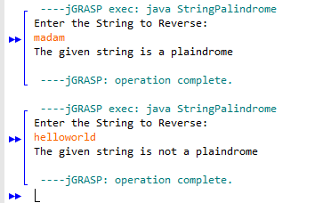

|  |
| --- |
| **Done by:**  **M.Gayathri**  **3rd year-CSE-‘A’**  **1712022** |